Project two: Palmprint recognition

1. Framework of Biometric System

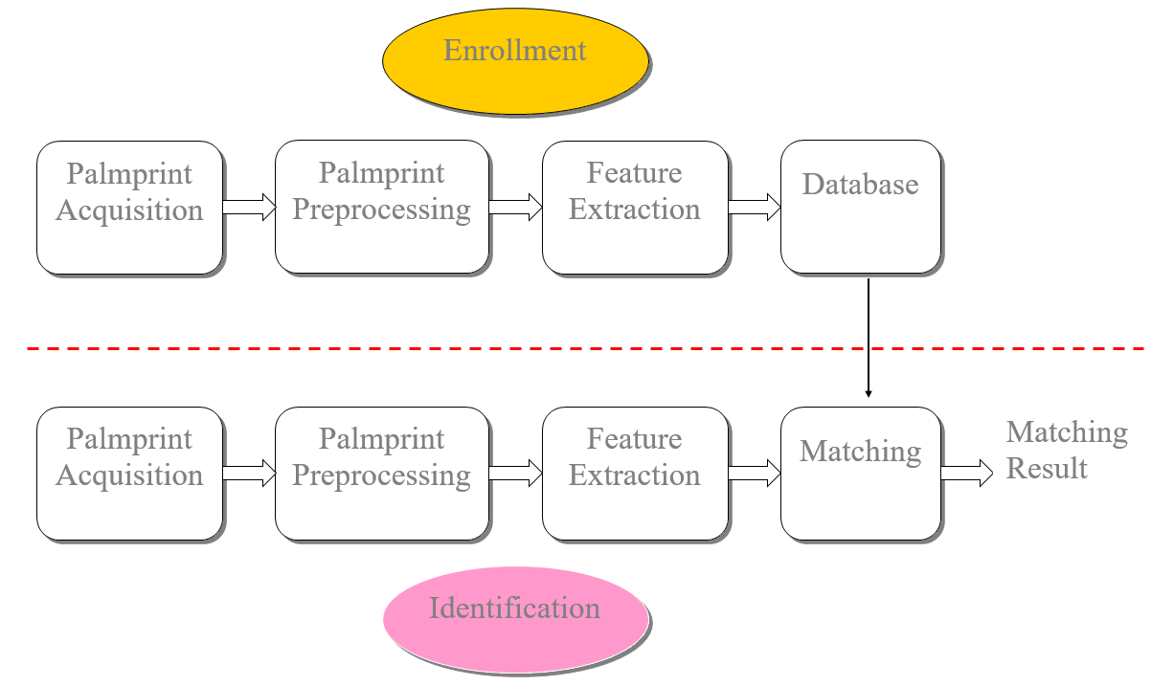

Figure 1. Framework of Biometric System

1. Feature Extraction
2. Main Lines and Wrinkles Extraction

As shown in Figure 2, the main lines and wrinkles in the palmprint image are the most important feature and the main basis for palmprint recognition. The main line is a collective term for "head line", "heart line", and "life line", which everyone has. Wrinkles are not necessarily available to everyone, but if there are, it will be more helpful for recognition.

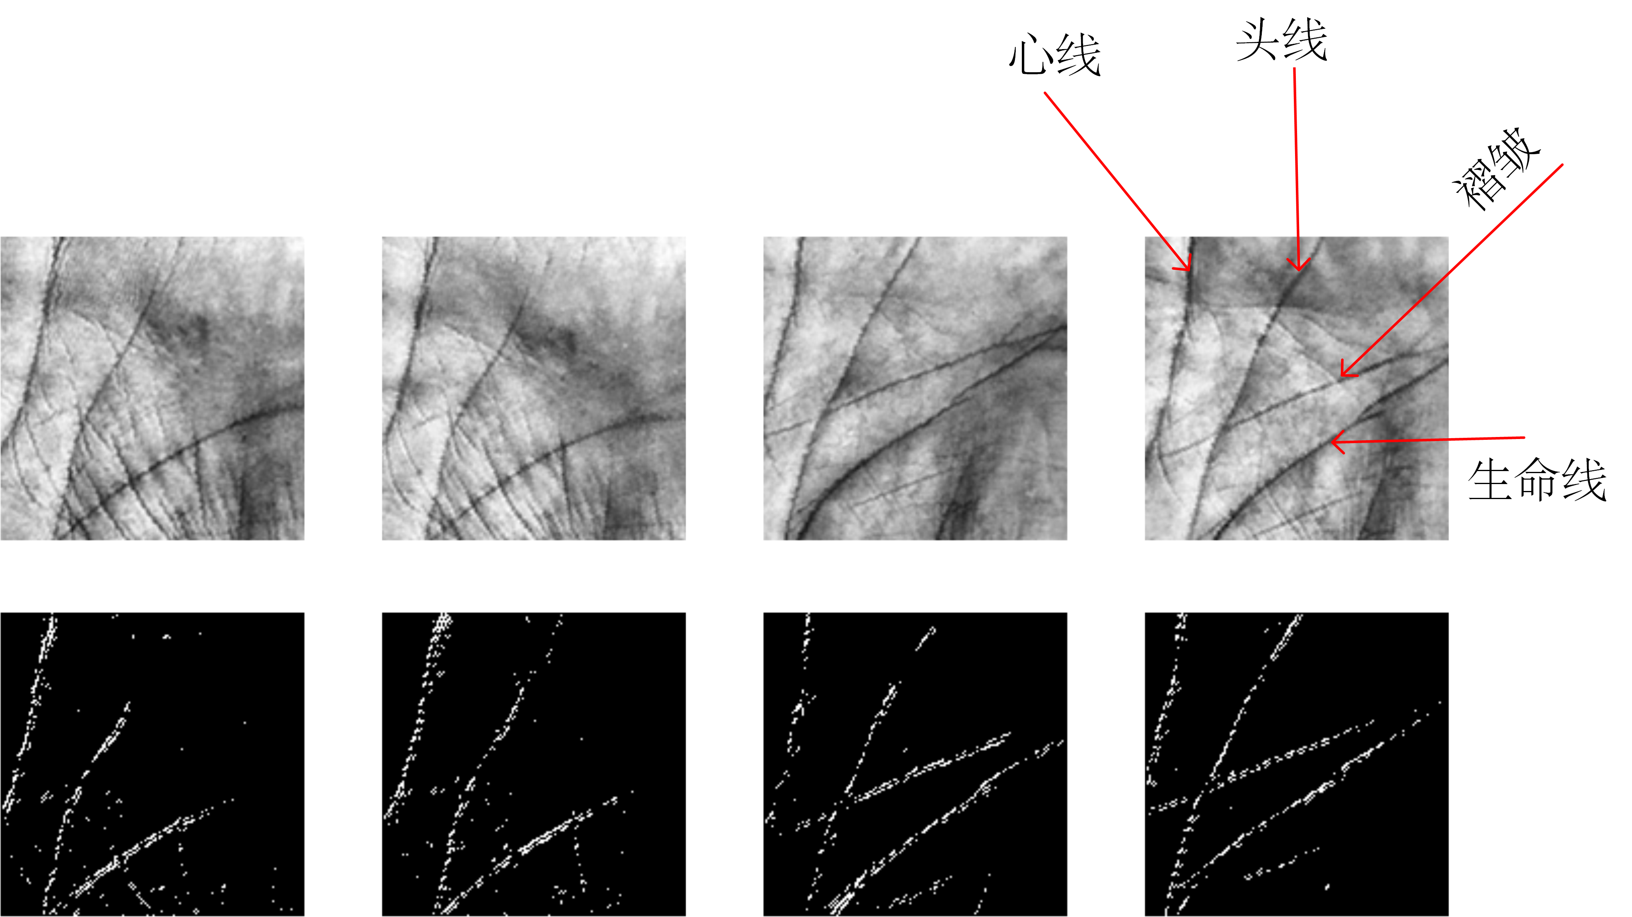

Figure 2. Main Lines and Wrinkles in Palmprint

1. Texture Feature Extraction

There are lots of texture features in palmprints, matching palmprint images with texture features is also a feasible idea. Moreover, you can even combine main lines features and texture features to improve the recognition rate. If you want to utilize texture features, please design an algorithm to extract them, such as Wavelet transform, Gabor filters, LBP, etc.

1. Feature Matching

The main core of palmprint feature matching is to design a matching function to describe the distance (or similarity) of two extracted palmprint features. The smaller the matching distance, the more likely the two samples are from the same person. For example, you can use Euclidean distance, Hamming distance or Cosine similarity for palmprint matching. You can also use other matching function if it will contribute to better recognition rate.

1. Dataset

There are 120 palmprint images captured from 20 persons. When collecting the images, each one was asked to contribute 6 samples. For each individual, 3 palmprint images are placed under the “training” folder and the rest are placed in the “testing” folder.

Please use the images in folder “training” for registration and recognize the images in folder “testing” and give your recognition accuracy.

Attention:

1. The programming language is not limited, you **can** call library functions.
2. You need to submit the source code and a brief report.
3. Submission format: ‘Pro2_student ID_name.zip/rar’, and Please send to: [1224624112@qq.com](mailto:1224624112@qq.com).
4. Deadline: 12.00 am on June 15, 2020
5. Most Important: Do it by yourself!